CST 363

Final Project

Ken Vader

Chris Pina

Ngoan Nguyen

**Database Entity Relationship Diagrams:**

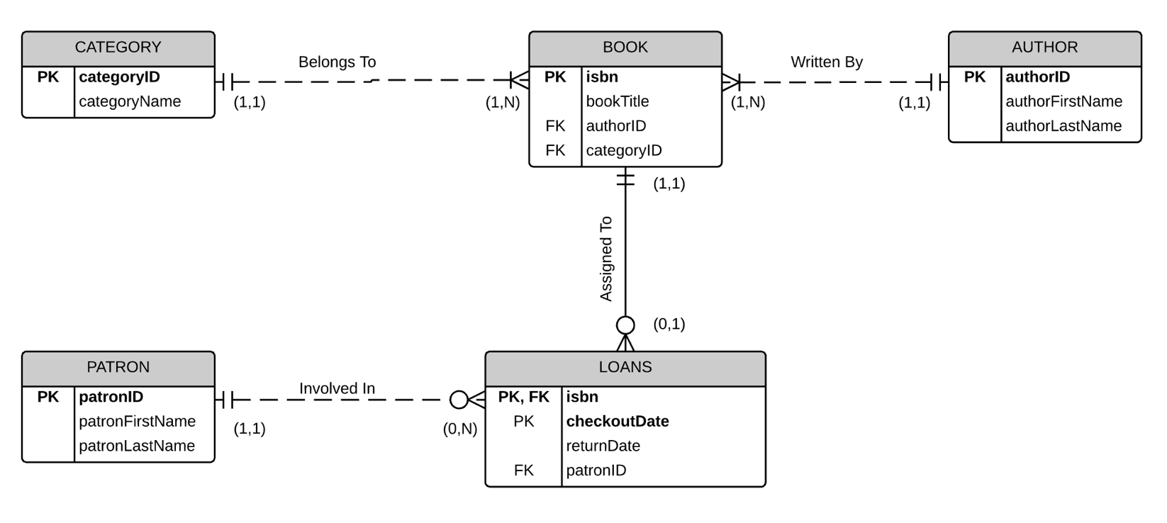

**Business Rules**

For the purposes of this assignment, we will assume the following rules apply.

* Each book will belong to one category
* A category may be applied to many books
* An author may write many books
* A book will only be written by one author
* A loan will be associated with only one patron
* A patron may have more than one loan
* A loan will contain only one book
* A book can only be loaned once per day
* A book may belong to one loan or no loans